1. Drivers:
2. Register:

* Choose Register/Driver Register on the menu to reach the driver’s register page:

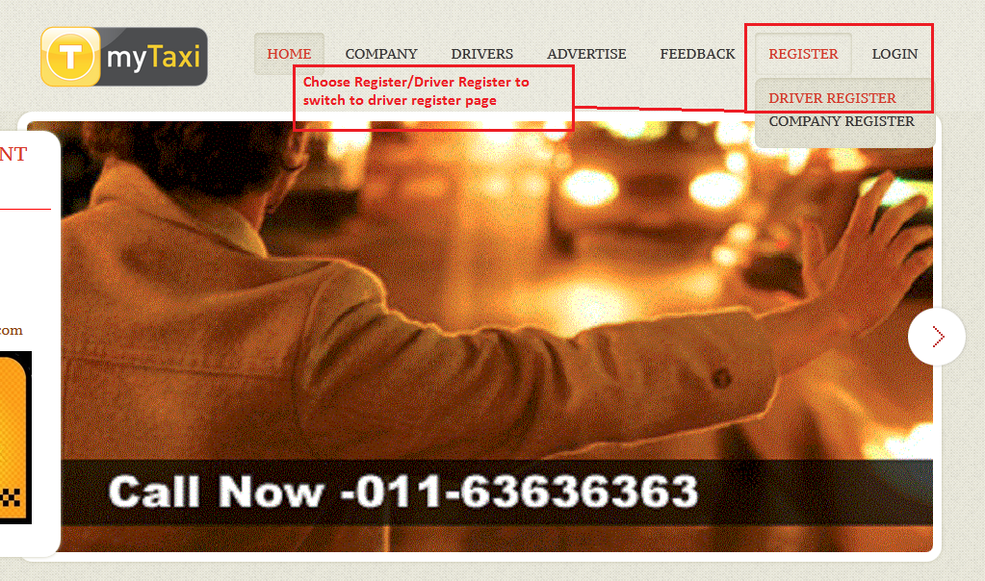

* In DriverRegister.xhtml page, fill your informations into the textboxes then click REGISTER button:

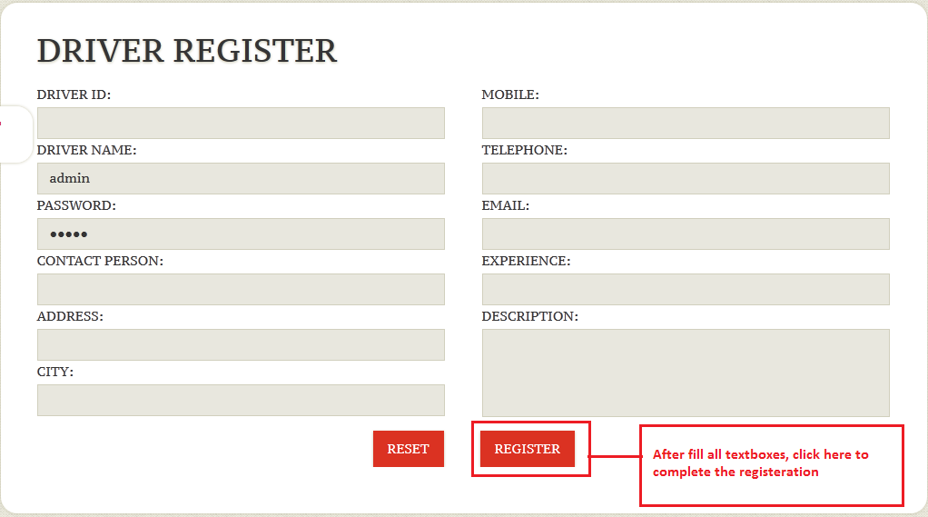

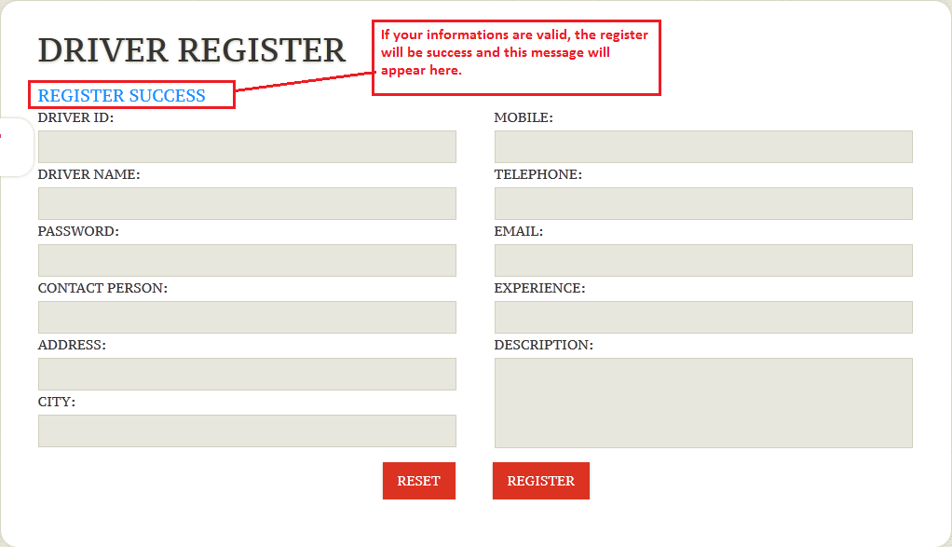

1. Driver’s Business:

* After register successfull, you can login (use your ID and Password you have just registered at previous step):

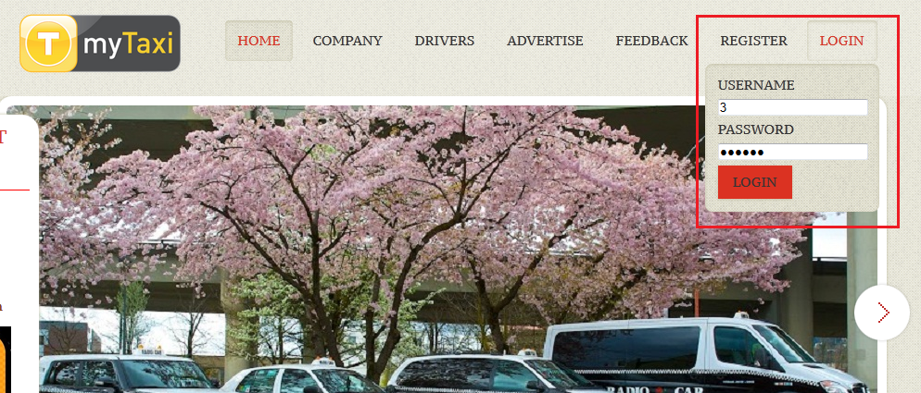

* Click Login, then you will reach to your informations’ page and you can see the toolsbar at the top-right side of screen:

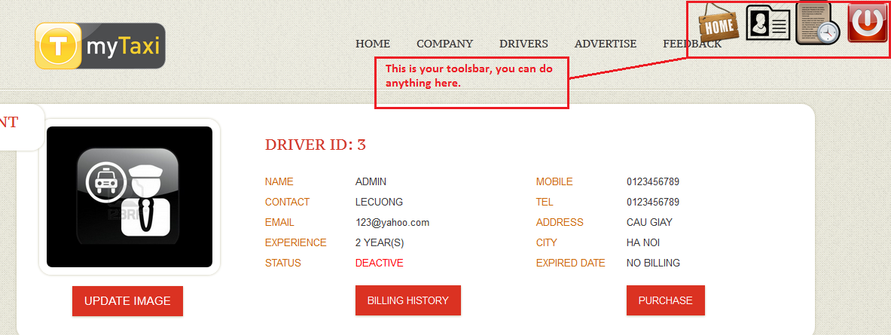

* Then, driver must purchase the first billing to active his account. Click on Purchase button, choose the Payment type and click Pay Now:

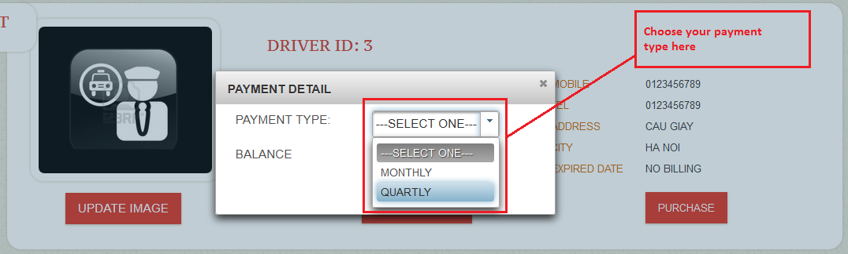

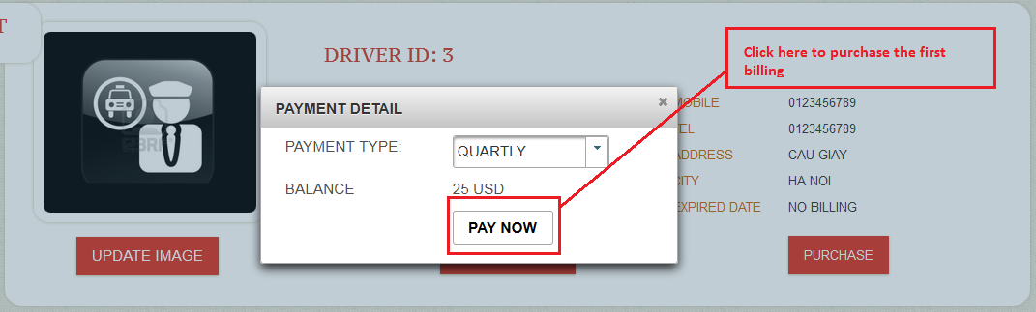

* Then, driver’s account has just been active, he can see his billing history if click Billing History button:

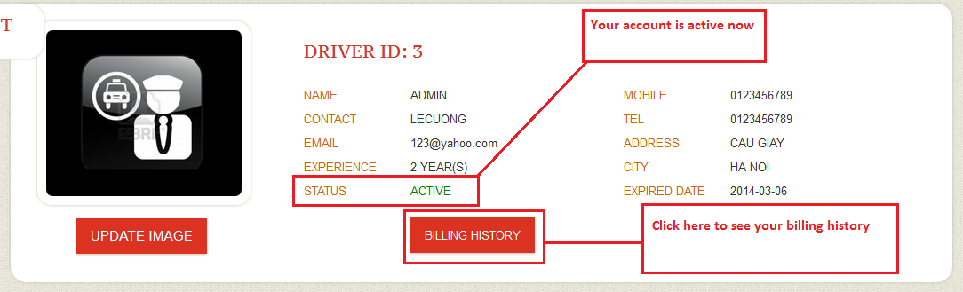

* Driver’s billing history page:

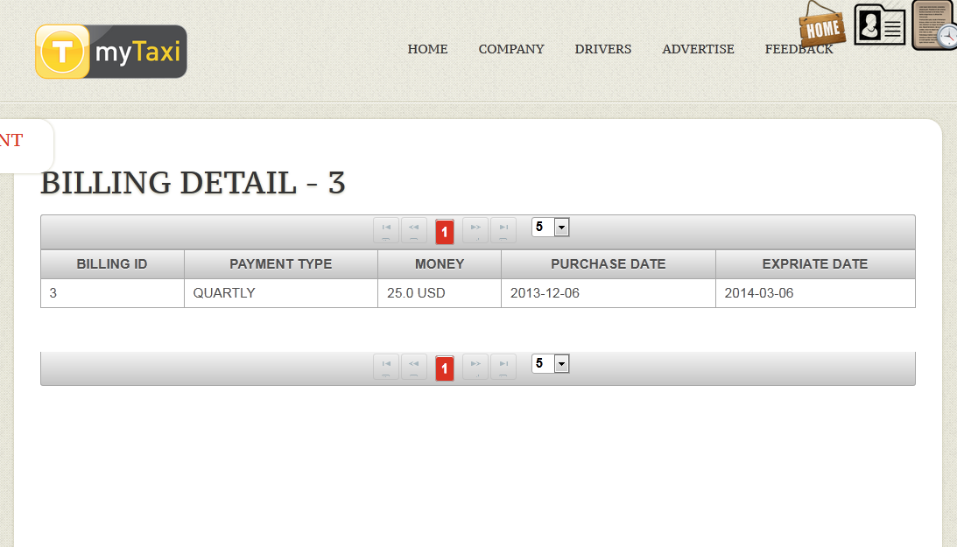

* Get back to driver’s informations page: he can update his image by click on UPDATE IMAGE button:

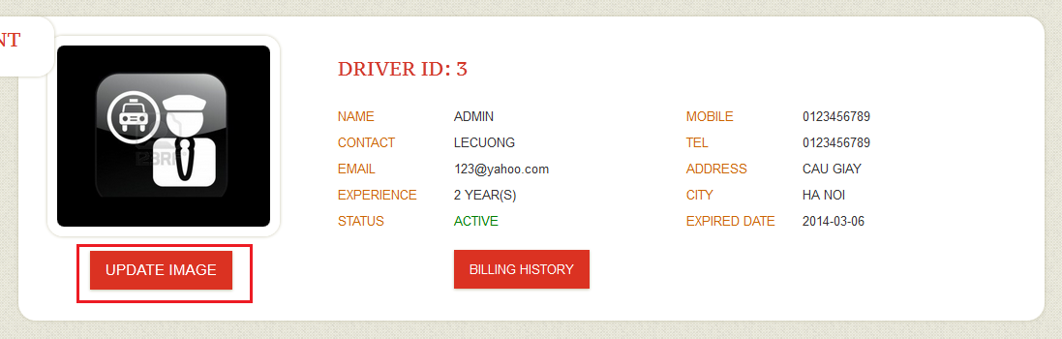

* Choose his image then click Upadate button:

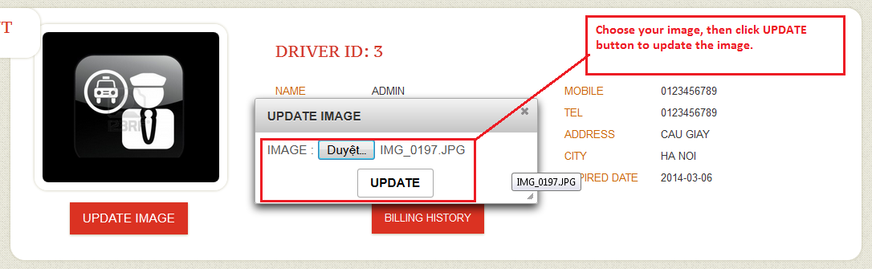

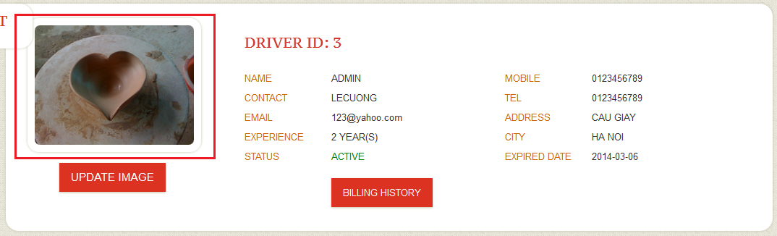

1. Company:
2. Register:

* Choose Register/Company Register